Most regular fairs wheels are boring or are considered more romantic but are still put into thriller theme parks today. But the invention of the double fairs wheel is a nice even for both regular fairs wheel riders and someone who wants something more thrilling. Why is that? The double fairs wheel can be changed and moved to make the ride more thrilling or tamer. We will find out what is best for everyone!

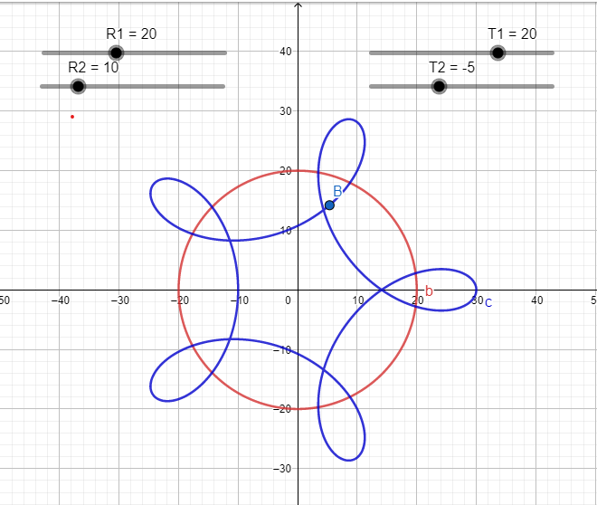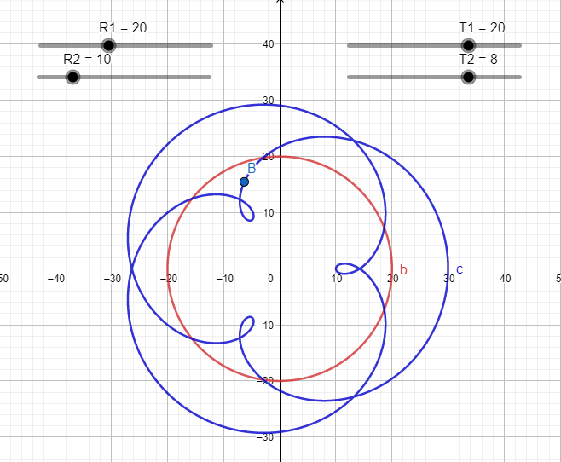For are base double fairs wheel, the center wheel will have a radius of 20 feet, and the 2 other wheels will have a radius of 10 feet. If we made both wheels have 1 rotation every 20 seconds this would create a regular fairs wheel experience, the rider would just go around in a perfect circle, making the double fairs wheel would be pointless. However, if we were to change the rotation of the 2 outer wheels to 1 full rotation every 8 seconds it would create a ride experience similar to the picture shown in Figure 1. Point B shows the rider, as point b gets closer and closer to the center of the circle the rider will get slower and slower because the center does not need to move as fast to get around the full circle as the outside, but what this also means is that the further you get from the center the faster the ride and the more thrilling! However, if the rider is always on the outside or always on the inside this would create a regular fairs wheel experience so there needs to be fluctuation.

Figure 2

Figure 1

If we where to move the outer fairs wheel counterclockwise instead of clockwise with the rest of the wheel it would create an experience shown in Figure 2. Because the rider moves faster the farther it is away from the circle these loops that we can see would whip the rider around and could be very uncomfortable if the device was moving fast enough. Another Thing we can do is look at the speed both circles are rotating at to find the number of loops. For example, in figure 1 we need to find the least common multiple of 20 and 8. That would be 40. we will then divide 40 by both 20 and 8 getting us 2 and 5 respectively. (LargerDividedMultiple – SmallerDivided Multiple) = Number of loops. So, in this case: |5 – 2| will get us 3 loops, seen in figure 1. The same can be done with figure 2. |(1-(-4)) |= 5 witch is true. There are many correlations between the radius and the Speeds of the circle to measure thrill or number of loops the rider will go through before it becomes to much.